
National Textile University
Department of Computer Science
Subject:
Mobile Application Development
Submitted To:
Sir Rehan Sarwar
Submitted By:
Alishba Riasat
Registration No:
23-NTU-CS-1135
Lab No:
05
Semester:
6th

Phase 1:
Task 1.1
Create a 200x200 Container with a unique background color
Code:
import 'package:flutter/material.dart';

void main() => runApp(const MyApp());

class MyApp extends StatelessWidget {
const MyApp({super.key});

@override
Widget build(BuildContext context) {
return const MaterialApp(
home: GestureScreen(),
);
}
}

class GestureScreen extends StatefulWidget {
const GestureScreen({super.key});

@override
State<GestureScreen> createState() => _GestureScreenState();
}

class _GestureScreenState extends State<GestureScreen> {
@override
Widget build(BuildContext context) {
return Scaffold(
appBar: AppBar(title: const Text('Phase 1 - GestureDetector')),
body: Center(
child: Container(
width: 200,
height: 200,
color: Colors.deepPurple, // unique starting color
),
),
);
}
}
Task 1.2
Wrap the Container in a GestureDetector
Code:
import 'package:flutter/material.dart';

void main() => runApp(const MyApp());

class MyApp extends StatelessWidget {
const MyApp({super.key});

@override
Widget build(BuildContext context) {
return const MaterialApp(
home: GestureScreen(),
);
}
}

class GestureScreen extends StatefulWidget {
const GestureScreen({super.key});

@override
State<GestureScreen> createState() => _GestureScreenState();
}

class _GestureScreenState extends State<GestureScreen> {
@override
Widget build(BuildContext context) {
return Scaffold(
appBar: AppBar(title: const Text('Phase 1 - GestureDetector')),
body: Center(
child: GestureDetector( // Task 1.2
child: Container( // Task 1.1
width: 200,
height: 200,
color: Colors.deepPurple,
),
),
),
);
}
}
Task 1.3
Add onTap, onDoubleTap, and onLongPress logic
Code:
import 'package:flutter/material.dart';
import 'dart:math';

void main() => runApp(const MyApp());

class MyApp extends StatelessWidget {
const MyApp({super.key});

@override
Widget build(BuildContext context) {
return const MaterialApp(
home: GestureScreen(),
);
}
}

class GestureScreen extends StatefulWidget {
const GestureScreen({super.key});

@override
State<GestureScreen> createState() => _GestureScreenState();
}

class _GestureScreenState extends State<GestureScreen> {
// Original values
final Color _originalColor = Colors.deepPurple;
final double _originalRadius = 0;

Color _boxColor = Colors.deepPurple;
double _borderRadius = 0;
bool _isCircle = false;

// List of colors to pick randomly from
final List<Color> _colors = [
Colors.red,
Colors.green,
Colors.blue,
Colors.orange,
Colors.pink,
Colors.teal,
Colors.amber,
Colors.cyan,
];

void _onTap() {
setState(() {
// Pick a random color from the list
_boxColor = _colors[Random().nextInt(_colors.length)];
});
}

void _onDoubleTap() {
setState(() {
// Toggle between square and circle
_isCircle = !_isCircle;
_borderRadius = _isCircle ? 100 : 0;
});
}

void _onLongPress() {
// Reset to original state
setState(() {
_boxColor = _originalColor;
_borderRadius = _originalRadius;
_isCircle = false;
});

// Show snackbar
ScaffoldMessenger.of(context).showSnackBar(
const SnackBar(
content: Text('Resetting...'),
duration: Duration(seconds: 1),
),
);
}

@override
Widget build(BuildContext context) {
return Scaffold(
appBar: AppBar(title: const Text('Phase 1 - GestureDetector')),
body: Center(
child: GestureDetector(
onTap: _onTap,
onDoubleTap: _onDoubleTap,
onLongPress: _onLongPress,
child: AnimatedContainer(
duration: const Duration(milliseconds: 300),
width: 200,
height: 200,
decoration: BoxDecoration(
color: _boxColor,
borderRadius: BorderRadius.circular(_borderRadius),
),
),
),
),
);
}
}

Output:
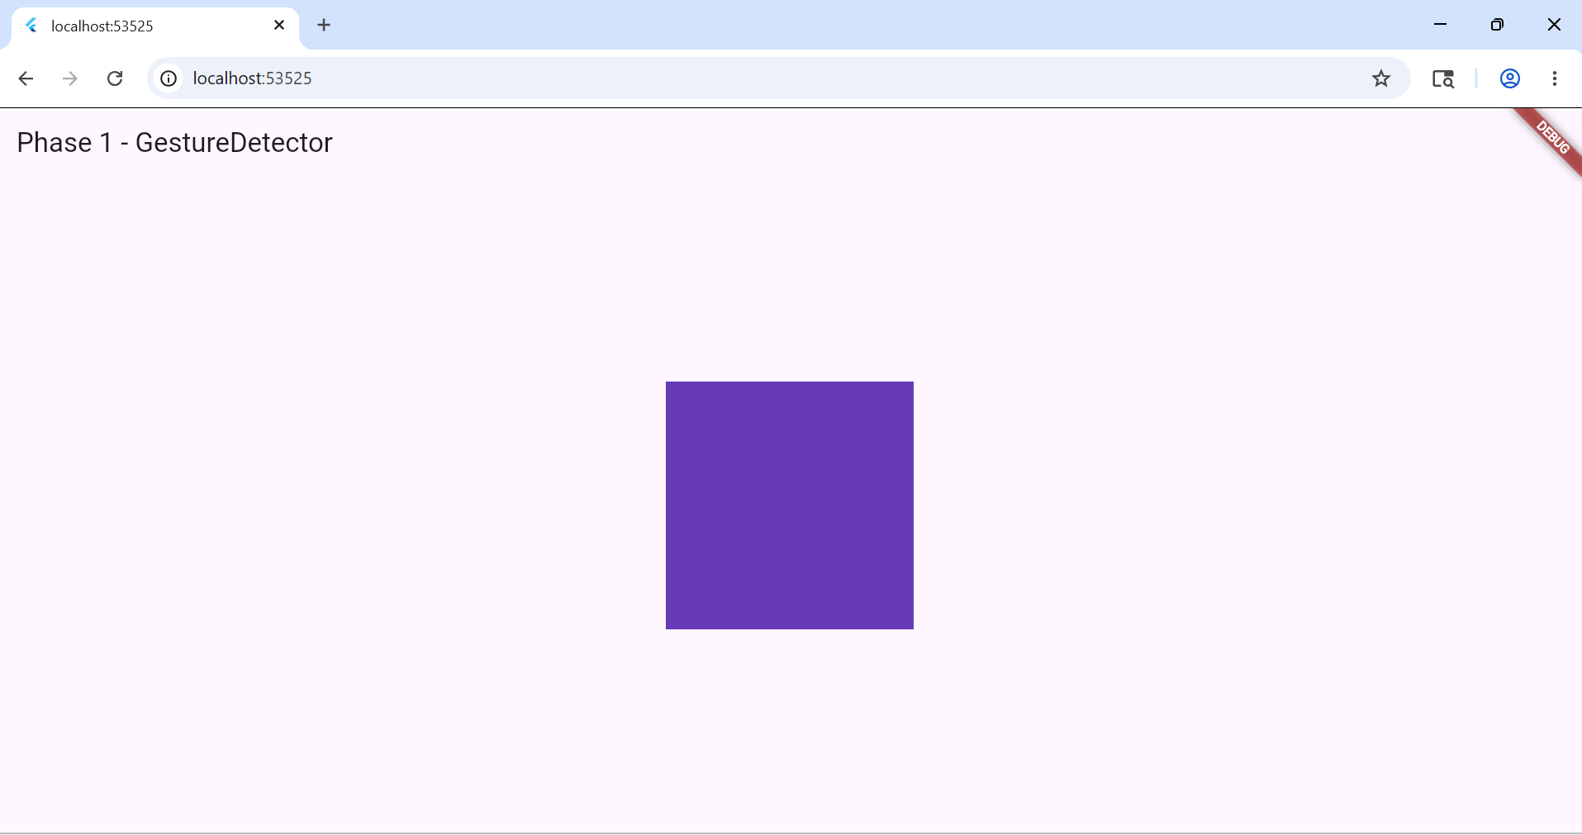

Phase 2:
Task 2.1
Column with a Text widget displaying a "Value" variable
Code:
import 'package:flutter/material.dart';

void main() => runApp(const MyApp());

class MyApp extends StatelessWidget {
const MyApp({super.key});

@override
Widget build(BuildContext context) {
return const MaterialApp(
home: SliderScreen(),
);
}
}

class SliderScreen extends StatefulWidget {
const SliderScreen({super.key});

@override
State<SliderScreen> createState() => _SliderScreenState();
}

class _SliderScreenState extends State<SliderScreen> {
double _value = 0.0;

@override
Widget build(BuildContext context) {
return Scaffold(
appBar: AppBar(title: const Text('Phase 2 - Sliders')),
body: Center(
child: Column(
mainAxisAlignment: MainAxisAlignment.center,
children: [
Text(
'Value: ${_value.toStringAsFixed(1)}',
style: const TextStyle(fontSize: 24),
),
],
),
),
);
}
}

Task 2.2
Add a Material Slider with min, max, divisions and onChanged
Code:
class _SliderScreenState extends State<SliderScreen> {
double _value = 0.0;

@override
Widget build(BuildContext context) {
return Scaffold(
appBar: AppBar(title: const Text('Phase 2 - Sliders')),
body: Center(
child: Column(
mainAxisAlignment: MainAxisAlignment.center,
children: [
Text(
'Value: ${_value.toStringAsFixed(1)}',
style: const TextStyle(fontSize: 24),
),
Slider(
value: _value,
min: 0.0,
max: 100.0,
divisions: 10,
label: _value.toStringAsFixed(1),
onChanged: (newValue) {
setState(() {
_value = newValue;
});
},
),
],
),
),
);
}
}

Task 2.3
Add CupertinoSlider below the Material one
Code:
import 'package:flutter/material.dart';
import 'package:flutter/cupertino.dart';

void main() => runApp(const MyApp());

class MyApp extends StatelessWidget {
const MyApp({super.key});

@override
Widget build(BuildContext context) {
return const MaterialApp(
home: SliderScreen(),
);
}
}

class SliderScreen extends StatefulWidget {
const SliderScreen({super.key});

@override
State<SliderScreen> createState() => _SliderScreenState();
}

class _SliderScreenState extends State<SliderScreen> {
double _value = 0.0;
double _cupertinoValue = 0.0;

@override
Widget build(BuildContext context) {
return Scaffold(
appBar: AppBar(title: const Text('Phase 2 - Sliders')),
body: Center(
child: Column(
mainAxisAlignment: MainAxisAlignment.center,
children: [
Text(
'Material Value: ${_value.toStringAsFixed(1)}',
style: const TextStyle(fontSize: 24),
),
Slider(
value: _value,
min: 0.0,
max: 100.0,
divisions: 10,
label: _value.toStringAsFixed(1),
onChanged: (newValue) {
setState(() {
_value = newValue;
});
},
),
const SizedBox(height: 40),
Text(
'Cupertino Value: ${_cupertinoValue.toStringAsFixed(1)}',
style: const TextStyle(fontSize: 24),
),
CupertinoSlider(
value: _cupertinoValue,
min: 0.0,
max: 100.0,
divisions: 10,
onChanged: (newValue) {
setState(() {
_cupertinoValue = newValue;
});
},
),
],
),
),
);
}
}

Output:
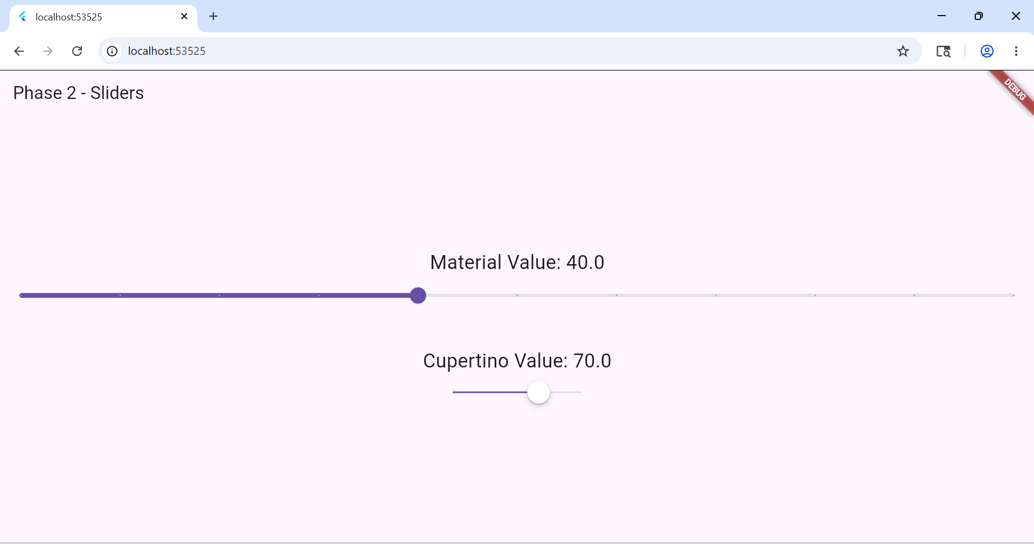

Phase 3:
Task 3.1
Three Sliders controlling RGB channels with a preview box
Code:
import 'package:flutter/material.dart';

void main() => runApp(const MyApp());

class MyApp extends StatelessWidget {
const MyApp({super.key});

@override
Widget build(BuildContext context) {
return const MaterialApp(
home: ColorMixerScreen(),
);
}
}

class ColorMixerScreen extends StatefulWidget {
const ColorMixerScreen({super.key});

@override
State<ColorMixerScreen> createState() => _ColorMixerScreenState();
}

class _ColorMixerScreenState extends State<ColorMixerScreen> {
double _red = 0;
double _green = 0;
double _blue = 0;

@override
Widget build(BuildContext context) {
return Scaffold(
appBar: AppBar(title: const Text('Phase 3 - Color Mixer')),
body: Center(
child: Column(
mainAxisAlignment: MainAxisAlignment.center,
children: [
Container(
width: 200,
height: 200,
decoration: BoxDecoration(
color: Color.fromRGBO(
_red.toInt(),
_green.toInt(),
_blue.toInt(),
1.0,
),
borderRadius: BorderRadius.circular(12),
),
),
const SizedBox(height: 30),
Row(
children: [
const SizedBox(width: 16),
const Text('R', style: TextStyle(color: Colors.red, fontSize: 18)),
Expanded(
child: Slider(
value: _red,
min: 0,
max: 255,
activeColor: Colors.red,
onChanged: (val) => setState(() => _red = val),
),
),
],
),
Row(
children: [
const SizedBox(width: 16),
const Text('G', style: TextStyle(color: Colors.green, fontSize: 18)),
Expanded(
child: Slider(
value: _green,
min: 0,
max: 255,
activeColor: Colors.green,
onChanged: (val) => setState(() => _green = val),
),
),
],
),
Row(
children: [
const SizedBox(width: 16),
const Text('B', style: TextStyle(color: Colors.blue, fontSize: 18)),
Expanded(
child: Slider(
value: _blue,
min: 0,
max: 255,
activeColor: Colors.blue,
onChanged: (val) => setState(() => _blue = val),
),
),
],
),
],
),
),
);
}
}
Task 3.2
Long Press on preview box to copy Hex code to console
Code:
class _ColorMixerScreenState extends State<ColorMixerScreen> {
double _red = 0;
double _green = 0;
double _blue = 0;

String _getHexCode() {
return '#'
'${_red.toInt().toRadixString(16).padLeft(2, '0')}'
'${_green.toInt().toRadixString(16).padLeft(2, '0')}'
'${_blue.toInt().toRadixString(16).padLeft(2, '0')}'
.toUpperCase();
}

@override
Widget build(BuildContext context) {
return Scaffold(
appBar: AppBar(title: const Text('Phase 3 - Color Mixer')),
body: Center(
child: Column(
mainAxisAlignment: MainAxisAlignment.center,
children: [
GestureDetector(
onLongPress: () {
final hex = _getHexCode();
debugPrint('Copied Hex: $hex');
ScaffoldMessenger.of(context).showSnackBar(
SnackBar(content: Text('Hex Copied: $hex')),
);
},
child: Container(
width: 200,
height: 200,
decoration: BoxDecoration(
color: Color.fromRGBO(
_red.toInt(),
_green.toInt(),
_blue.toInt(),
1.0,
),
borderRadius: BorderRadius.circular(12),
),
),
),
const SizedBox(height: 30),
Row(
children: [
const SizedBox(width: 16),
const Text('R', style: TextStyle(color: Colors.red, fontSize: 18)),
Expanded(
child: Slider(
value: _red,
min: 0,
max: 255,
activeColor: Colors.red,
onChanged: (val) => setState(() => _red = val),
),
),
],
),
Row(
children: [
const SizedBox(width: 16),
const Text('G', style: TextStyle(color: Colors.green, fontSize: 18)),
Expanded(
child: Slider(
value: _green,
min: 0,
max: 255,
activeColor: Colors.green,
onChanged: (val) => setState(() => _green = val),
),
),
],
),
Row(
children: [
const SizedBox(width: 16),
const Text('B', style: TextStyle(color: Colors.blue, fontSize: 18)),
Expanded(
child: Slider(
value: _blue,
min: 0,
max: 255,
activeColor: Colors.blue,
onChanged: (val) => setState(() => _blue = val),
),
),
],
),
],
),
),
);
}
}

Task 3.3
Horizontal Drag to scale the preview box up or down
Code:
import 'package:flutter/material.dart';

void main() => runApp(const MyApp());

class MyApp extends StatelessWidget {
const MyApp({super.key});

@override
Widget build(BuildContext context) {
return const MaterialApp(
home: ColorMixerScreen(),
);
}
}

class ColorMixerScreen extends StatefulWidget {
const ColorMixerScreen({super.key});

@override
State<ColorMixerScreen> createState() => _ColorMixerScreenState();
}

class _ColorMixerScreenState extends State<ColorMixerScreen> {
double _red = 0;
double _green = 0;
double _blue = 0;
double _boxSize = 200;

String _getHexCode() {
return '#'
'${_red.toInt().toRadixString(16).padLeft(2, '0')}'
'${_green.toInt().toRadixString(16).padLeft(2, '0')}'
'${_blue.toInt().toRadixString(16).padLeft(2, '0')}'
.toUpperCase();
}

@override
Widget build(BuildContext context) {
return Scaffold(
appBar: AppBar(title: const Text('Phase 3 - Color Mixer')),
body: Center(
child: Column(
mainAxisAlignment: MainAxisAlignment.center,
children: [
GestureDetector(
onLongPress: () {
final hex = _getHexCode();
debugPrint('Copied Hex: $hex');
ScaffoldMessenger.of(context).showSnackBar(
SnackBar(content: Text('Hex Copied: $hex')),
);
},
onHorizontalDragUpdate: (details) {
setState(() {
_boxSize += details.delta.dx;
_boxSize = _boxSize.clamp(50, 350);
});
},
child: AnimatedContainer(
duration: const Duration(milliseconds: 50),
width: _boxSize,
height: _boxSize,
decoration: BoxDecoration(
color: Color.fromRGBO(
_red.toInt(),
_green.toInt(),
_blue.toInt(),
1.0,
),
borderRadius: BorderRadius.circular(12),
),
),
),
const SizedBox(height: 30),
Text(
_getHexCode(),
style: const TextStyle(fontSize: 20, fontWeight: FontWeight.bold),
),
const SizedBox(height: 16),
Row(
children: [
const SizedBox(width: 16),
const Text('R', style: TextStyle(color: Colors.red, fontSize: 18)),
Expanded(
child: Slider(
value: _red,
min: 0,
max: 255,
activeColor: Colors.red,
onChanged: (val) => setState(() => _red = val),
),
),
],
),
Row(
children: [
const SizedBox(width: 16),
const Text('G', style: TextStyle(color: Colors.green, fontSize: 18)),
Expanded(
child: Slider(
value: _green,
min: 0,
max: 255,
activeColor: Colors.green,
onChanged: (val) => setState(() => _green = val),
),
),
],
),
Row(
children: [
const SizedBox(width: 16),
const Text('B', style: TextStyle(color: Colors.blue, fontSize: 18)),
Expanded(
child: Slider(
value: _blue,
min: 0,
max: 255,
activeColor: Colors.blue,
onChanged: (val) => setState(() => _blue = val),
),
),
],
),
],
),
),
);
}
}

Output:
